MACHINE LEARNING MODEL EXPLORATION
Using Google Teachable Machine
Name: Maheswari
Course: MCA
Subject: Machine Learning / Practical
Platform: Google Teachable Machine

1. Introduction
Machine Learning is a branch of Artificial Intelligence that enables computers to learn patterns from data and make predictions. In this experiment, Google Teachable Machine is used to create a simple image classification model without advanced programming.
The model is trained to classify waste into three categories: plastic, paper, and metal. Images of these waste categories are provided as training examples, after which the trained model is tested using new objects.

2. Objective
The main objectives of this experiment are:
- To explore a beginner-friendly Machine Learning platform.
- To understand the basic concept of image classification.
- To collect and organize training examples.
- To train a simple Machine Learning model.
- To test the model using new images.
- To observe how training data affects predictions.
- To understand a basic real-world application of AI in waste management.

Page 3 — Tool and Dataset
3. Platform Used
Google Teachable Machine
Teachable Machine is a browser-based tool that allows users to create simple Machine Learning models using images, sounds, or poses without requiring advanced programming knowledge.
Model Configuration
Parameter | Description
Platform | Google Teachable Machine
Model Type | Image Classification
Input | Webcam Images
Number of Classes | 3
Class 1 | Plastic Waste
Class 2 | Paper Waste
Class 3 | Metal Waste

4. Training Dataset
The model was trained using images of common waste materials.
Class | Examples
Plastic Waste | Bottle, plastic cover, container
Paper Waste | Paper, newspaper, cardboard
Metal Waste | Tin can, spoon, metal container
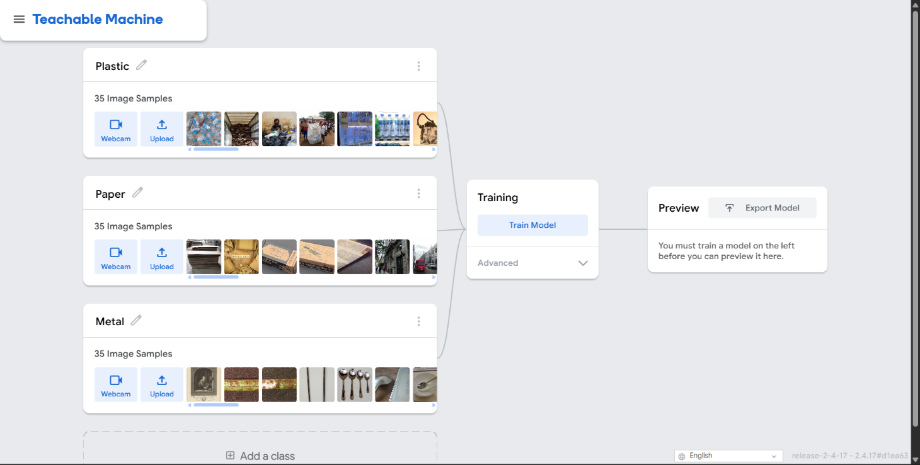Figure 1: Training dataset preparation

Page 4 — Model Training
5. Training Process
The collected images were assigned to their respective classes. The Train Model option was then selected.
The system learned visual patterns from the provided examples and generated an image classification model.
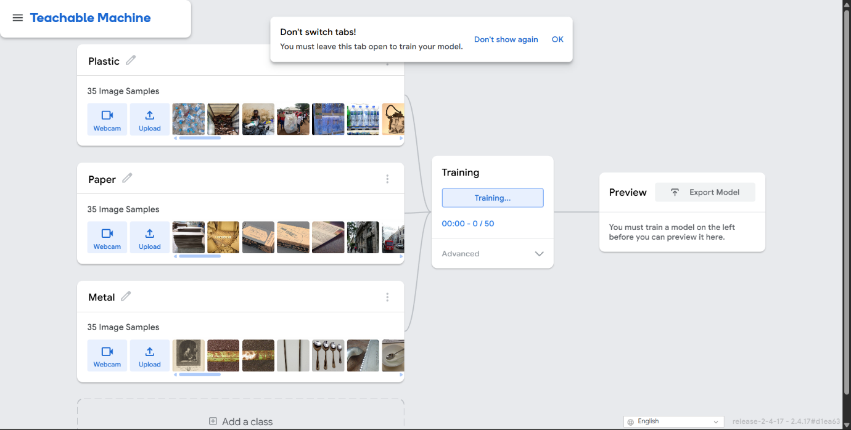Figure 2: Training the waste classification model

Basic Workflow
Training Images
↓
Class Labels
↓
Machine Learning Training
↓
Trained Model

Page 5 — Testing
6. Model Testing
After training was completed, the model was tested using new objects through the webcam.
Test 1 — Plastic
Input: New plastic bottle
Prediction: Plastic Waste
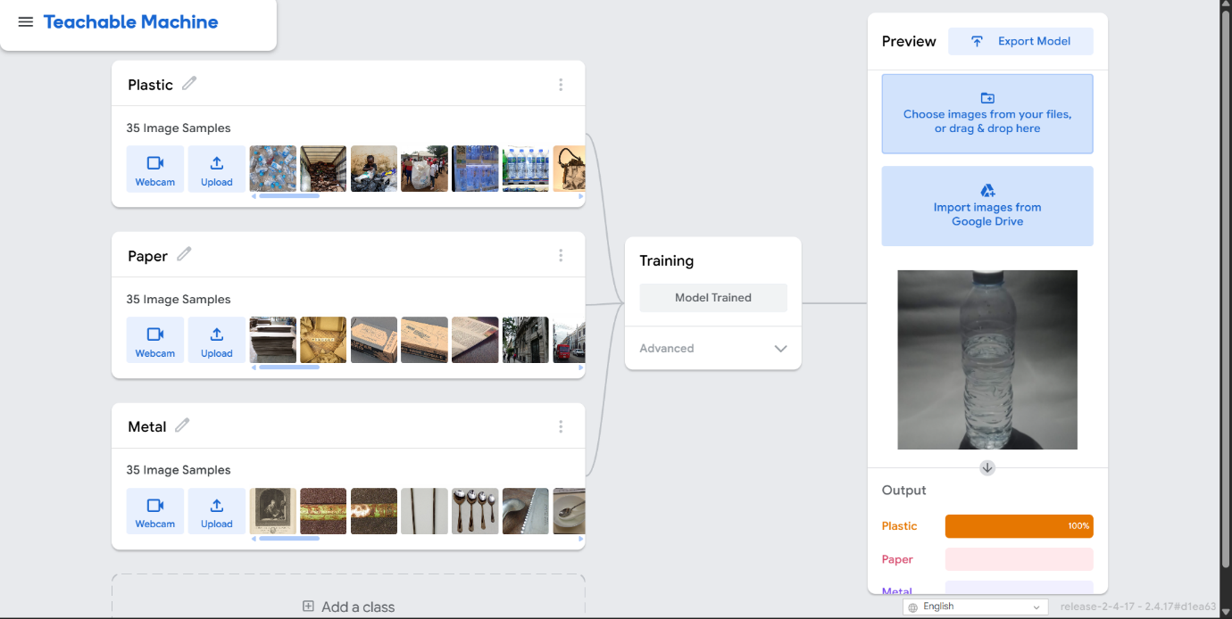
Figure 3: Plastic waste prediction

Test 2 — Paper
Input: New paper/newspaper
Prediction: Paper Waste
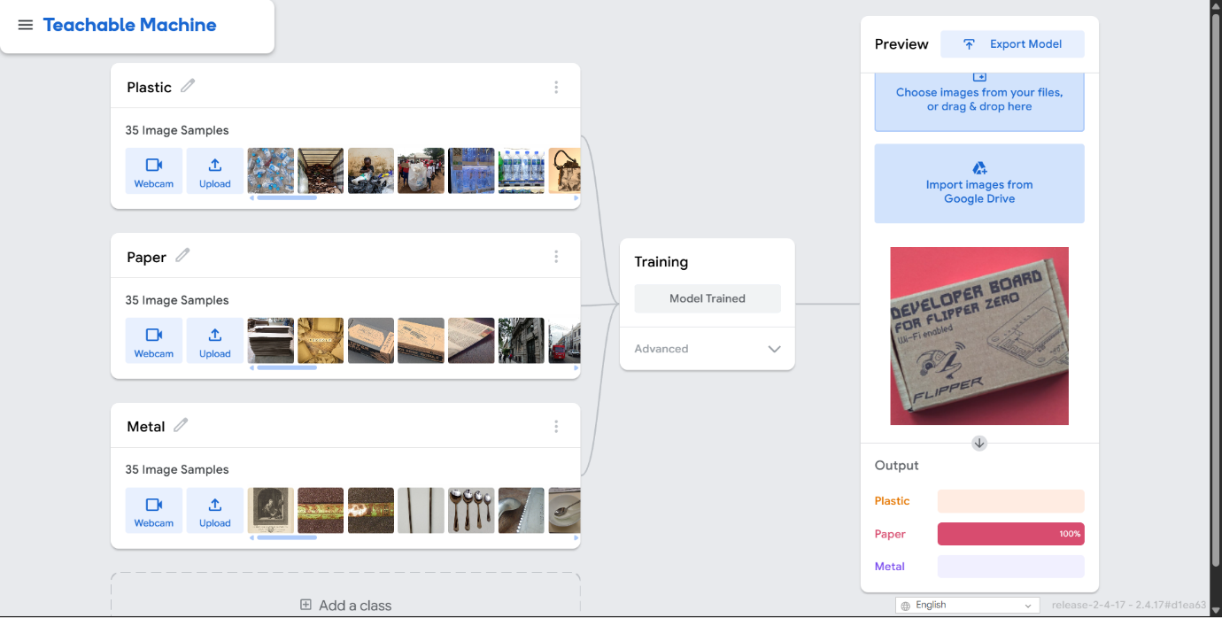Figure 4: Paper waste prediction
Test 3 — Metal
Input: New metal object
Prediction: Metal Waste
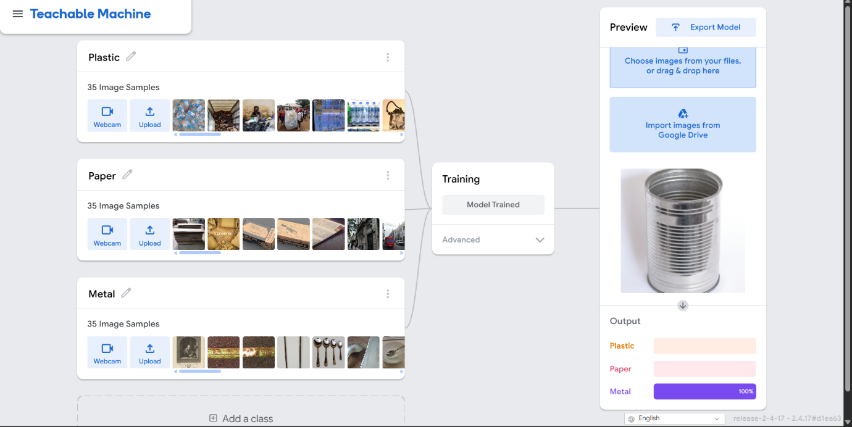Figure 5: Metal waste prediction

Page 6 — Experiment Results
7. Results
Create this table using your actual observations:
Test | Input Object | Actual Category | Model Prediction | Result
1 | Plastic bottle | Plastic | Plastic | Correct
2 | Newspaper | Paper | Paper | Correct
3 | Metal can | Metal | Metal | Correct
4 | Glass bottle | Not trained | ______ | Observation
Don't claim 100% accuracy unless you actually evaluated enough independent test examples to justify it.
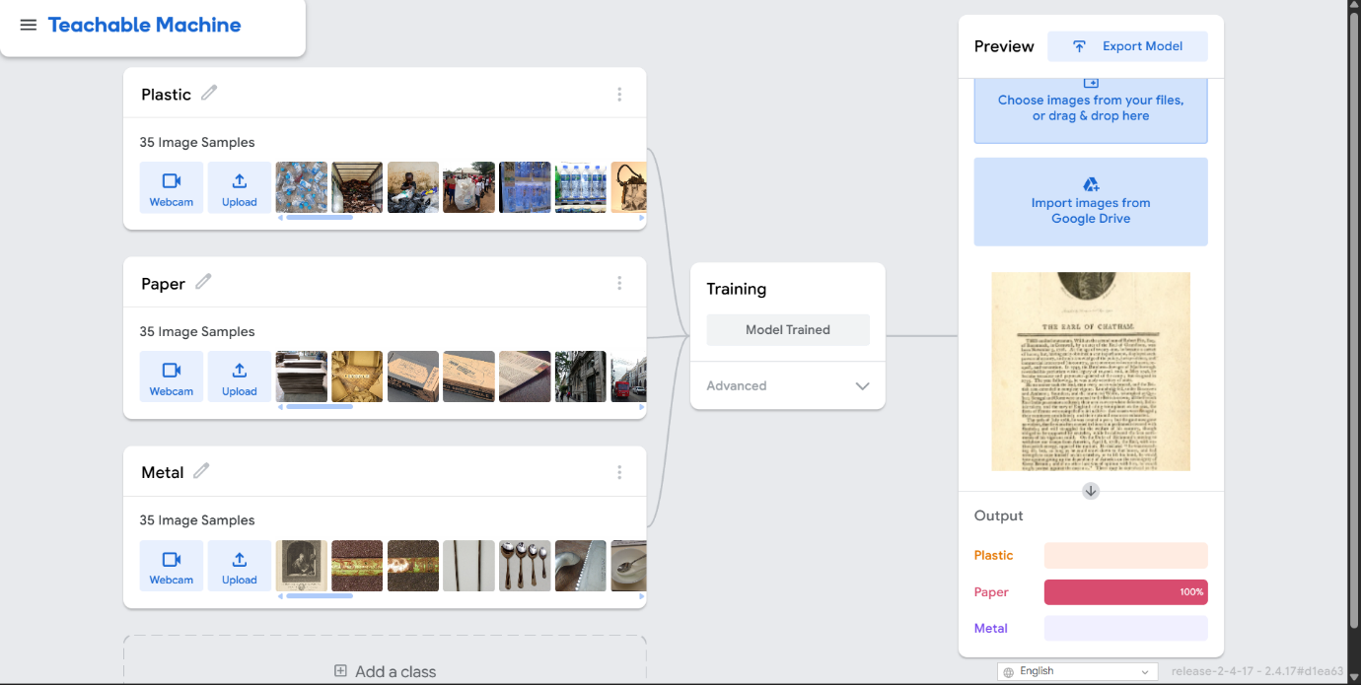
Page 7 — Observation
8. Observations
The experiment demonstrated that the model can learn visual patterns from examples and use those patterns to classify new images.
The prediction can change depending on:
- Quality of training images
- Lighting conditions
- Object position
- Camera angle
- Background
- Similarity between objects
- Number and variety of training examples
Testing an object outside the training categories also showed that a basic classifier will still select from its available classes rather than necessarily identifying the object correctly.

Page 8 — Real-World Application & Conclusion
9. Real-World Application
The concept can be extended to smart waste-management systems.
Camera
↓
Waste Image
↓
AI / ML Model
↓
Waste Classification
↓
Plastic / Paper / Metal
↓
Smart Sorting System
Possible applications include:
- Smart waste bins
- Automated waste sorting
- Recycling systems
- Environmental monitoring
- Waste-management assistance

10. Conclusion
This experiment provided basic hands-on experience with Machine Learning using Google Teachable Machine. An image classification model was created using three waste categories: plastic, paper, and metal. The model was trained using example images and subsequently tested with new objects.
The activity demonstrated the fundamental Machine Learning workflow of collecting data, training a model, providing new input, and obtaining a prediction. It also showed how training-data quality and testing conditions can influence the model's predictions.

